**Aquaculture Veterinarians in the North Central Region**

Compiled by **Dr. Myron Kebus**

Aquaculture Outreach Veterinarian

Assistant Professor of Health Programs

Department of Pathobiology and Diagnostic Investigation

College of Veterinary Medicine

Michigan State University

608-616-2133

[kebusmyr@msu.edu](mailto:kebusmyr@msu.edu)

Updated July 13, 2024

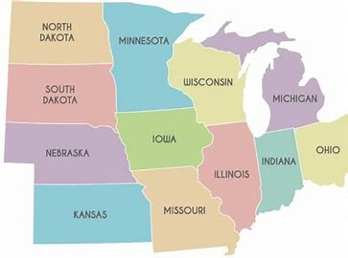

1

4

3

5

2

2

2

2

1

The veterinarians listed provided their information including the states in which they are licensed to practice and are available to provide aquaculture veterinary services to commercial farms in the region. Currently, there were no veterinarians that provided information for the following North Central states: Iowa, Kansas, Missouri, Nebraska, North Dakota. **If you are a veterinarian and would like to be added to this list, please send an email to** [kebusmyr@msu.edu](mailto:kebusmyr@msu.edu).

**ILLINOIS**

Dr. Gascho

**INDIANA**

Dr. Gascho

**IOWA**

Dr. Starling

**MICHIGAN**

Dr. Gascho

**MINNESOTA**

Dr. Fox

**OHIO**

Dr. Gascho

**SOUTH DAKOTA**

Dr. Fox

**WISCONSIN**

Dr. Marty

Dr. Vandever

**PRIVATE PRACTICE VETERINARIANS**

**1. Dr. Jessica Fox DVM, CertAqV**

MN

Cell:507-401-6592

[Finsfeathursfurandfetlocks@gmail.com](mailto:Finsfeathursfurandfetlocks@gmail.com)

**2. Dr. Daniel C. Gascho, DVM**

Four Star Veterinary Service, LLC

Office: 765-985-2344 ǀ [swinehealthcare@4starvets.com](mailto:swinehealthcare@4starvets.com)

4015 North Mexico Road, Mexico, IN 46958

Ambulatory/Consulting

**3. Dr. Marty Martin**

Central Wisconsin Ag Services

Alma Center, WI

(847)-873-9045

[andrewedwardmartin@gmail.com](mailto:andrewedwardmartin@gmail.com)

**4. Dr. David E. Starling, D.V.M.**

Aqueterinary Services®, P.C.

626 South Marshall St.

Boone, IA 50036

C: 515-490-6285

F: 866-311-4710

E: [aquavet@aqueterinary.com](mailto:aquavet@aqueterinary.com)

**5. Dr. David M. Vandever, DVM**

Innovative Veterinary Services

12381 W St Martins Rd, Franklin, WI 53132

414-248-0267

[dmvandever@gmail.com](mailto:dmvandever@gmail.com)